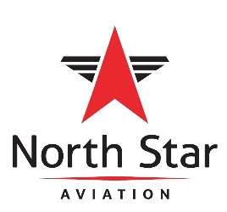

Position Title: Line Service Technician, Part-Time
Position Reports to: Line Service Manager
Classification: Exempt
Date: 10/19

Purpose:
Provide ground service for all sizes of aircraft.
Tasks:
- Provide ground service for all sizes of aircraft, for example: marshall aircraft on arrival and departure, including proper placement of chocks and cones, refueling, ground power units, towing, and deicing.
- Wing walking.
- Greet passengers, pilots and crew.
- Handle aviation fuels to include fueling and towing aircraft, maintaining quality control of fuel through various procedures and completing applicable paperwork required daily.
- Maintain a professional appearance and manner with all customers and employees.
- Perform any requested customer service duties.
- Adhere to all safety policies as outlined by North Star Aviation.
- Use Exceptional interpersonal and communication skills to communicate with coworkers and customers.
Education & Experience:
Highschool Diploma or equivalent
Previous experience in Line Service duties is a helpful, but not required.
Must have a valid state ID

Physical/ Environmental Demands:
- Frequent standing, walking, bending, stooping, reaching, pushing, pulling.
- Ability to lift/carry up to 50 lbs. routinely and up to 100 lbs. occasionally
- Must have high situational awareness
- Frequent work in small places, extreme temperatures, heights above six feet and noisy environments.

EEO/AAP/Drug Free Workplace

